Assignment 2
Lab: C++ Parallel Programming

Akanksha Jadhao | PRN : 260740150004
Pratik Abhang | PRN: 260740150018

Exercise 1: Parallel Element-Wise Vector Addition
**Objective:** Write a C++ program that performs element-wise addition of two integer arrays in parallel using OpenMP.
**Requirements:**
* Define two input arrays of size $N=6$ containing predefined integer values, and a third output array initialized to zero.
* Use the `#pragma omp parallel for` directive to distribute the addition loop across multiple threads (e.g., 3 threads).
* Inside the parallel loop, each thread must calculate the sum of corresponding elements from the input arrays and store the result in the output array.
* Use a `#pragma omp critical` section to safely print out which thread ID computed which index and result, ensuring the console output does not get garbled.

Program
#include <iostream>
#include <vector>
#include <omp.h>

int main() {
const int N = 6;
std::vector<int> A = {10, 20, 30, 40, 50, 60};
std::vector<int> B = {1, 2, 3, 4, 5, 6};
std::vector<int> C(N, 0);

// Set thread count to 3
omp_set_num_threads(3);

#pragma omp parallel for
for (int i = 0; i < N; ++i) {
C[i] = A[i] + B[i];

// Ensure console output is non-garbled
#pragma omp critical
{
std::cout << "Thread " << omp_get_thread_num()
<< " computed index " << i
<< ": " << A[i] << " + " << B[i] << " = " << C[i] << "\n";
}
}

std::cout << "\nFinal Output Array: ";
for (int val : C) {
std::cout << val << " ";
}
std::cout << "\n";

return 0;
}

OUTPUT
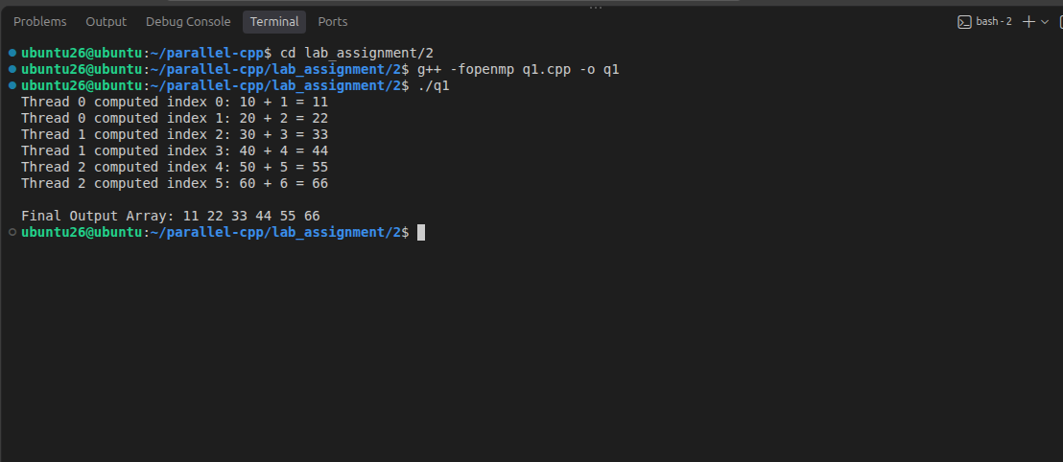

Exercise 2: Thread-Safe Array Summation with OpenMP Reduction
**Objective:** Write a C++ program that calculates the total sum of an integer array using parallel execution while preventing race conditions.
**Requirements:**
* Define an array of 8 integers with predefined values and a shared accumulator variable (`total_sum`) initialized to 0.
* Use the `#pragma omp parallel for` directive combined with the OpenMP **reduction** clause (`reduction(+:total_sum)`) using 4 threads.
* The reduction clause must automatically handle private thread accumulators and safely merge them into the final shared total without requiring manual critical sections.
* Print the final combined sum to the console after the parallel region completes.

Program
#include <iostream>
#include <vector>
#include <omp.h>

int main() {
std::vector<int> arr = {5, 12, 8, 20, 15, 3, 9, 11}; // Array of 8 integers
int total_sum = 0;

// Use OpenMP reduction clause with 4 threads
#pragma omp parallel for num_threads(4) reduction(+:total_sum)
for (size_t i = 0; i < arr.size(); ++i) {
total_sum += arr[i];
}

std::cout << "Final Total Sum: " << total_sum << "\n";

return 0;
}

OUTPUT
